13th May 2020
Year 1
Phonics: Alternative spellings for the ‘igh’ sound.
Watch this short video to introduce you to one way of spelling the ‘igh’ sound differently : https://www.youtube.com/watch?v=t0C01G_sCsQ
Then have a go at the activities here to practise identifying and sorting the different ‘igh’ sounds: https://www.phonicsplay.co.uk/member-only/ighAltSpellings.html?

English: Planning our diary/story
Now that you’ve had a good think about your special event, we are going to plan out our story/diary. Remember that in Gregory Cool he told us about how we got to Tobago, what he saw and how he felt throughout the story.
Have a go at planning your story/diary using the grid attached. (My example is attached if you need a guide!)
Remember to work in chronological order (from the beginning to the end) and write in short notes.
Talk through your story plan with an adult (this will help when it comes to writing your story tomorrow!).

Maths: Time

Can you remember where the hands need to be for it to be half past the hour?
(https://open.online.clickview.co.uk/libraries/videos/13078078/analogue-clocks-telling-time-to-half-past)
Here’s a handy hint: 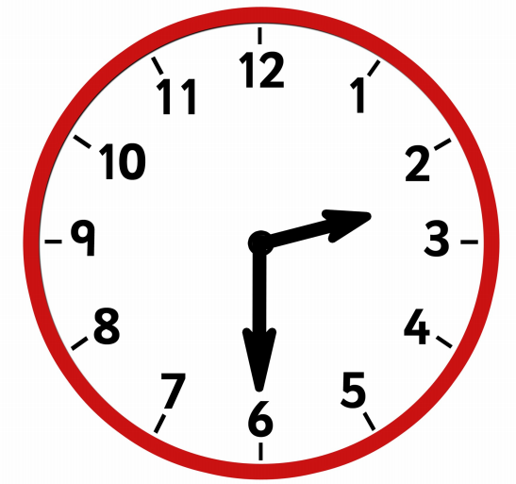
What time is being shown here?

Can you draw a clock showing the time half past 4?

When you are confident with half past on a clock, have a go at the activity attached (There are three different sets of challenges. Diving – if you’re wobbly, Deeper: Getting confident, Deepest: Absolutely smashing it!)
Topic: What is a compass?
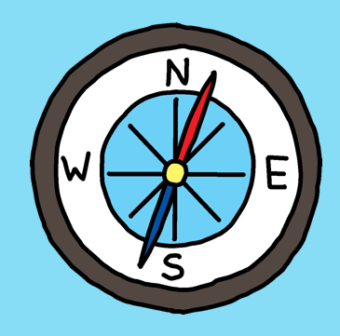

Compasses are really useful to find the direction we are facing. People use compasses to help find the direction of the sun in the sky and when they are out walking – especially when doing some ‘orienteering’.

The easy way to remember the different points on a compass is: Never Eat Shredded Wheat or Naughty Elephants Spray Water!

Ask your parents if they have a compass app on their phone (or a real compass!) and use the compass to give directions to people like: ‘take two steps north’.

There is an instruction activity sheet attached for you to follow the instructions to reach a destination!

