Proper nouns and common nouns
A proper noun is a name used for an individual person, place or organisation. The name will start with a capital letter.
Remember that common nouns are naming words. Nouns can be people, places or things.
Read each sentence. Underline or write the proper nouns in your book.
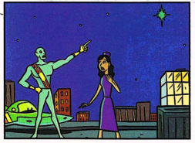
An alien pointed to a planet called Altron in the blue sky.

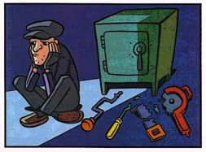
Alan, a silly thief, couldn’t open the safe at Natwest.

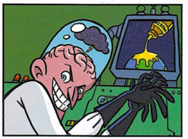
The scientist rubbed his hands together as he watched the screen and saw Earth covered in goo.
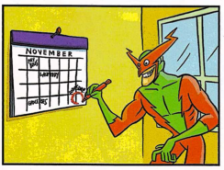
Dave was happy because it was Friday, his favourite day of the week.

Go back through and circle or write in a separate list any common nouns you have found.

