Tuesday 28th April English task

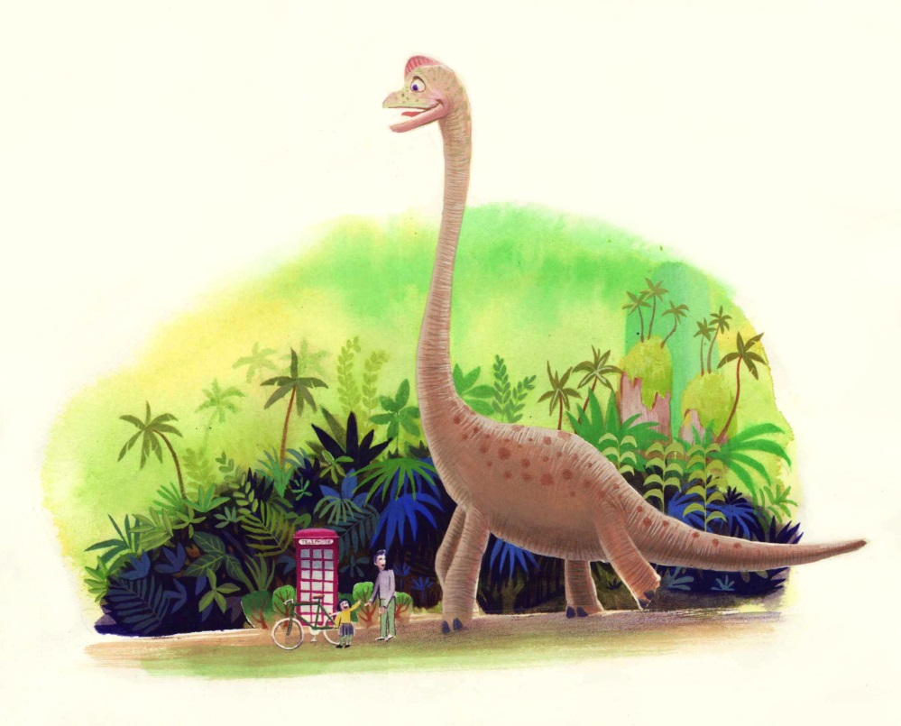

Look at the picture carefully . Write a short story about the dinosaur and the people in the picture. Make sure you make it as interesting as possible and it has a beginning, middle and ending
- Where is this?
- Why is the dinosaur here?
- Are there any others around?
- How old is this dinosaur?
- How does it feel about the people? How do the people feel about the dinosaur? Have they seen a dinosaur before?
- Where do you think it’s going? Is it looking for something?

Remember to use :
Capital letters and full stops
Interesting adjectives, verbs and adverbs
Conjunctions
Paragraphs
Open you sentences in different ways
Speech dialogue ,using inverted commas – “…… ”

