Wednesday 20th May 2020
Reception
Phonics  English | New sound ‘er’  Let’s learn with Mr Mc!  https://www.youtube.com/watch?v=H6Dh1NilBQg  Select Phase 3, then +er to sort words into he correct alien! https://www.phonicsplay.co.uk/member-only/PicnicOnPluto.html  Write the words: hammer, letter, dinner, better, summer, shorter, longer, powder (Select two or three of these words or if your child is up for a challenge, have a go at all of them.)  Poverty  What do you think the word poverty means?  Have a look at the PowerPoint attached to find out more.  Reception: (Adults: focus more on the ‘helping hand’ side of these pictures if you feel more comfortable) What can you see? How does it make you feel? What do these people need?  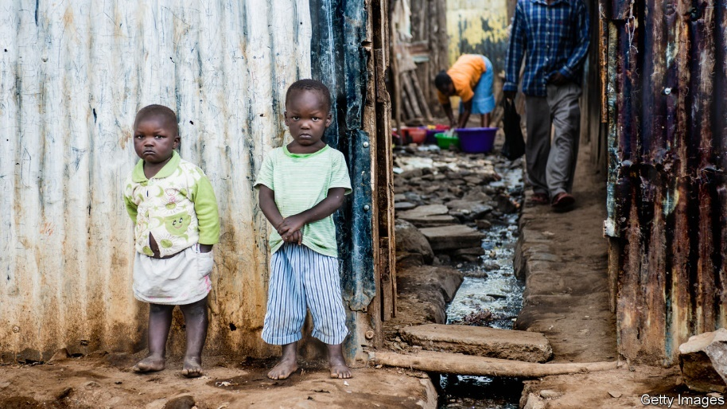  Then ask the children, how do you think we can help these people? If you saw these people in real life, what could we do to help?
Maths | Capacity  Full or Empty  Have a go at this activity: https://kids.classroomsecrets.co.uk/resource/reception-capacity-game/  See if you can match the labels with the bottles in this activity: https://kids.classroomsecrets.co.uk/resource/reception-capacity-matching-game/  Look in your fridge at the bottles or jars of liquid. Tell an adult if the jars/bottles are full or empty. Can you order them from empty to full?
Topic | Day three of being stuck under the sea! It seems the submarine can no longer be fixed!  That means it is up to us to create a vehicle which will be able to hold all of the class (21 people but don’t worry Ms Everett can drive it) all the way back to shore!  These are some things we have found whilst being stuck at the bottom of the ocean, could you use these in your design?  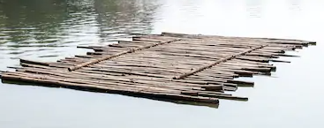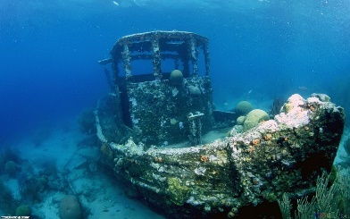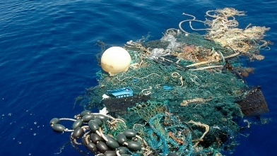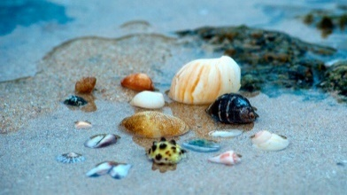  Have a go at the ‘How Fish Breathe’ science experiment

