Hedgehog Class Home Learning Thursday 2nd April 2020

English/Phonics

Mr Mc – Lesson 5 – Review ar, or, ur
Revising letter names and sounds – these are very important to learn to help when reading. The children are taught to sound talk words but if they don’t make sense the next step is to use the letter names to see if that helps.
Writing a list
Reading sentences – My doll and back pack are in the car. Do not burn the toast!
https://www.youtube.com/watch?v=5C2cbm5EebM

Teach dr (like sk/sc sounding like sg) dr may sound like jr but words do not start with these 2 letters.

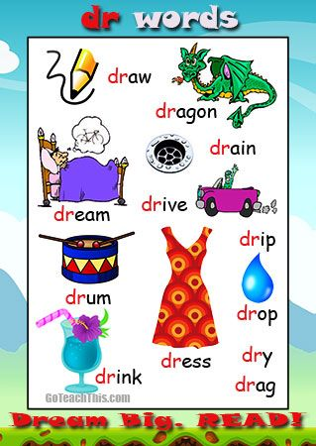
Can your child read/guess what the words are that start with dr?

Can they orally put some into a sentence?

Can they write a sentence using one or more of the dr words?

Challenge – could they write a story about a dragon!

Maths

Big Numbers Song on YouTube - https://www.youtube.com/watch?v=e0dJWfQHF8Y
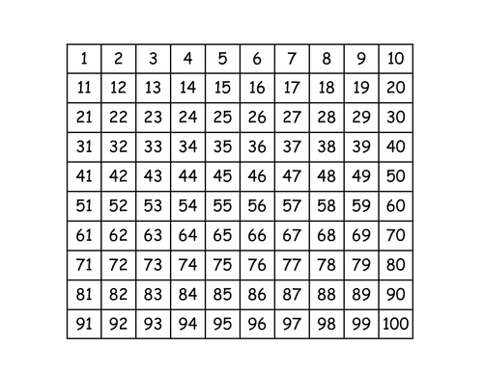
If you have access to a printer – you could print off a 100 square.
Your child could look for number patterns and colour them ie all the numbers ending in 0 colour yellow, all numbers ending in 4 colour red etc
What do they notice?
Which is the smallest number on the 100 square?
Largest number?
Which is their favourite number and why?
Can they start to learn to recognise then write numbers higher than 10/20/30 … ?

White Rose Maths Website - https://whiterosemaths.com/homelearning/early-years/
Week 1 – Easter Activities
Day 5 (Friday- know we are not quite there yet but there are lots of ideas that could continue over many days!!)
Topics covered are days of the week, decorating eggs, patterns including repeating patterns, egg and spoon race, counting whilst balancing an egg on a spoon, looking for seeds in the food we eat, exploring with cotton wool and using it to make Easter cards!

Change – think about the egg before you boil it – what is it like inside? How does it change after it has been cooked?

Making chocolate nests – what does the chocolate look like to begin with? How does it change as it is heated?

I am sure you will think of a lot more questions to ask as you complete the different activities.

Collective Worship

The Christian Story of Easter

https://www.bbc.co.uk/teach/class-clips-video/religious-studies-ks1-the-christian-story-of-easter/zhgv47h

I wonder if any of you were tricked today – April Fool’s Day!!!

