[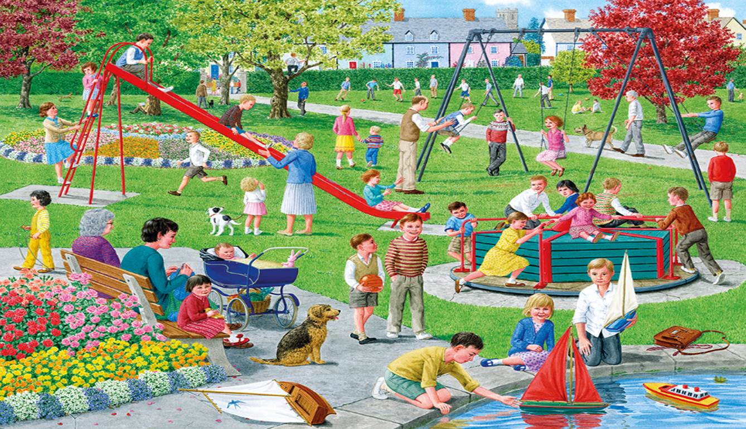](http://www.google.co.uk/url?sa=i&rct=j&q=&esrc=s&source=images&cd=&cad=rja&uact=8&ved=0CAcQjRw&url=http%3A%2F%2Fgalleryhip.com%2Fcartoon-street-scene.html&ei=E_JxVdDvEcyV7Abe4YOoDg&bvm=bv.95039771,d.ZGU&psig=AFQjCNHndM3LUb7gHXV-LIXCylqVzST71g&ust=1433617243638845)