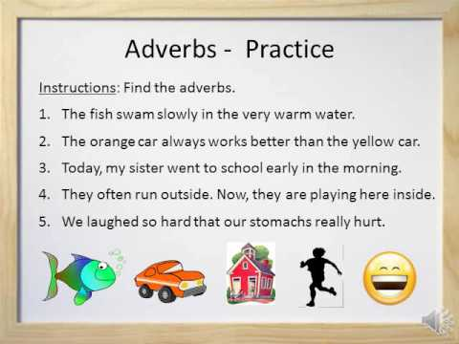
Adverbs - Practice
Instructions: Find the adverbs. 1. The fish swam slowly in the very warm water. 2. The orange car always works better than the yellow car. 3. Today, my sister went to school early in the morning. 4. They often run outside. Now, they are playing here inside. 5. We laughed so hard that our stomachs really hurt.

