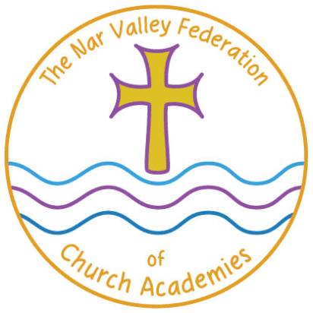
Nar Valley Federation

5-week Animal Project

For the next 5 weeks we are going to be working on an animal project. Mrs Neary thought that this would be a lovely way for the whole of the Federation to complete the last few weeks of this academic year.
Each week there will be a different element that looks at different habitats or types of animals. These will build up week on week to create your overall project, which we would like you to bring into school when we return, so that we can share and celebrate the learning that you have been doing.
- Week 1 – Nocturnal Animals
- Week 2 – Peru – South American Animals and Habitats
- Week 3 – Sea Creatures
- Week 4 – African Animals – The Savannah
- Week 5 – Endangered Animals

We will be covering all different areas of the curriculum during the weeks and providing links, videos and other useful resources and ideas.

Nar Valley Federation – Animal Project
African Animals- The Savannah

Vocabulary: savannah, habitat, ambled, ungainly, specimen, vile and grizzly, continent/s, food chain

Book Ideas:

EYFS / KS1
Lila and the Secret of Rain (Y2)
One Day on our Blue Planet: In the Savannah
Handa’s Surprise
Anna Hibiscus
Meerkat Mail
Long Walk to Freedom
All Aboard for the Bobo Road

EYFS / Y1

Task 1-

Watch or read ‘The Ugly Five’ by Julia Donaldson. Here is the link to a video if you do not have the story at home-
https://youtu.be/69K2IZ1A1ZU

Listen out for all the rhyming words in the story. Perhaps you could make your own rhyming dictionary using some of the words. Adding some illustrations of the rhyming words will really help it look exciting.

Task 2-

Think of some speech / thought bubbles to add to the illustrations. What are the animals saying / thinking?

Task 3-

Imagine that the title of the book was 'The Ugly Six'. Make another page based on a sixth member of the group. Research your animal and include some interesting adjectives in your description.
This task can be spread across a couple of days.

Year 2

Task 1-

Research what the collective nouns are to describe the different groups of animals. E.g. a group of warthogs live in a group called sounders!
You could use the internet and the search engine ‘Kiddle’ to find out.
You could also research the BIG five! What is a group of lions, leopards, buffalo, rhino’s and elephants called?
Make an eye catching poster with the animals on, which will make people want to go on an African Safari and see them all!

Task 2-

Imagine that the title of the book was ‘The Ugly Six’. Create a new page with a detailed illustration of your sixth animal. Can you include some adjectives and some interesting facts about your animal? You might even want to include some rhyme.
Don’t rush, you can spread this task over a couple of days.

Task 3-

Create your own retelling of the story. You might want to draw a story map, drawing pictures to show the ‘journey’ of the story or make some puppets. You could draw the characters and stick them onto a straw or stick. Perform your retelling of the story to someone else. You could even film it!

Science/ PSHE:  EYFS / KS1  Find out about the habitats of the Ugly Five, where do they live and what they need to survive.  Think about other habitats around the world-  *Polar regions  * The desert  * The rainforest  Think about why the Ugly Five wouldn’t be suited to living in other habitats around the world. E.g. where the vulture gets food that has been dead a while, why wildebeest aren’t suited to living in the desert and why the warthog would not like to live at the North Pole.  You could write the reasons why on a post it and put it on a map or you could just write your reasons in your book.  Shadows  The five ugly animals cast a long shadow in the sunshine. What are shadows? How are they formed?  Research this and share your findings.  This Bitesize clip might help-  https://www.bbc.co.uk/bitesize/clips/zntmhyc  PSHE  Look through the story and sort some of the words that the author uses to describe the animals (e.g. ugly, spindly, graceful, divine). Which ones are positive and which are negative?  How would you feel if somebody called you ugly?  The Ugly Five become a group of friends at the end of the story. What are the qualities of a good friend?  Think about 1 of your friends, what makes them a good friend? | Art  EYFS /KS1  Create an African landscape- you could make a model, draw, paint, use pastels- be as adventurous as you like!  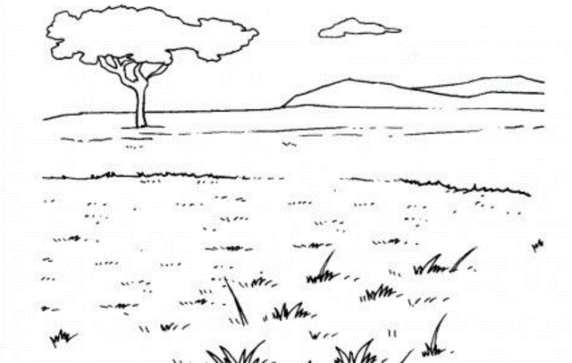  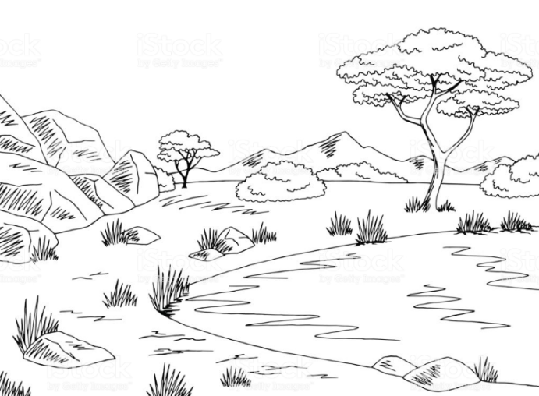  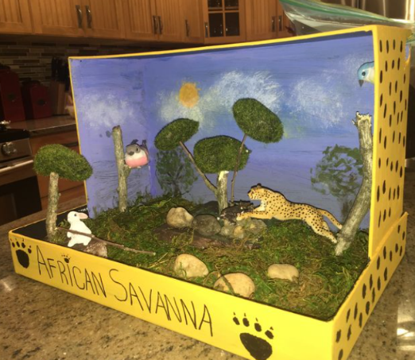  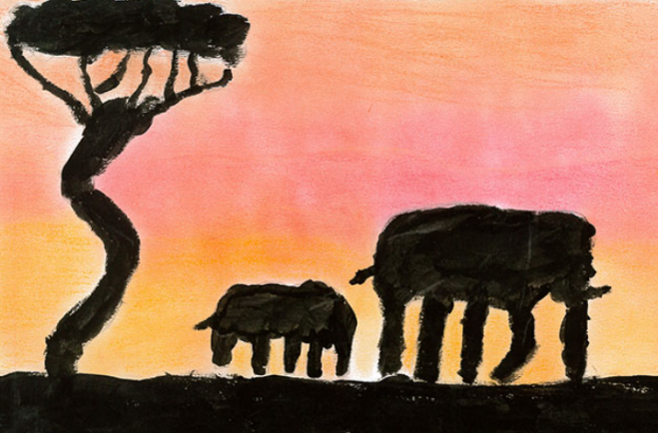  Make a food chain. You might want to discuss some ideas first or conduct some research using books and the internet.  Some facts to get you started! -  • Lappet-face vultures scavenge on carcasses of mammals such as gazelles and hares, but they also eat eggs, insects (such as locusts), and hunt live prey such as small birds (e.g. flamingoes).  • Spotted hyenas scavenge the leftovers of bigger predators, but will also hunt mammals such as wildebeest or antelope. They also kill and eat birds, lizards, snakes, and insects.  • Wildebeest are herbivorous animals and graze on grasses, leaves and shoots.  • Marabou storks are scavengers; they eat anything from termites, flamingos and small birds to leftover scraps of mammal carcasses (with vultures and hyenas).  • Warthogs mainly eat grass, fruit, berries, roots and insects but they are also known to occasionally eat small mammals, birds and reptiles.  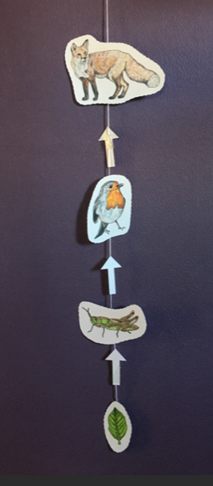An example of a food chain mobile.

