PE Challenge 2: Catch and Clap

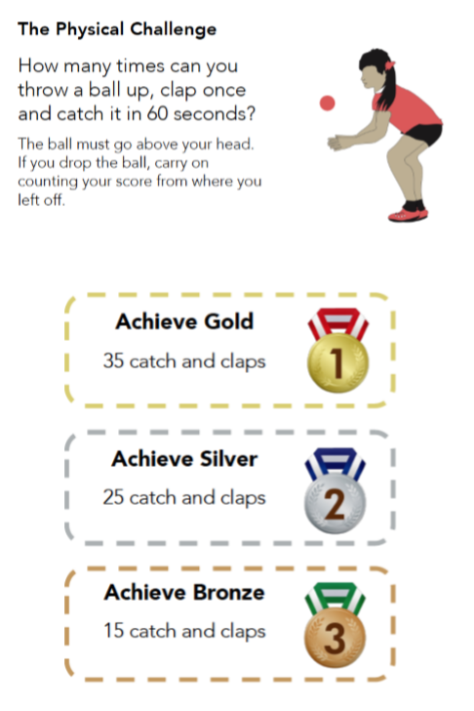

PE Challenge 3:Tap up tennis
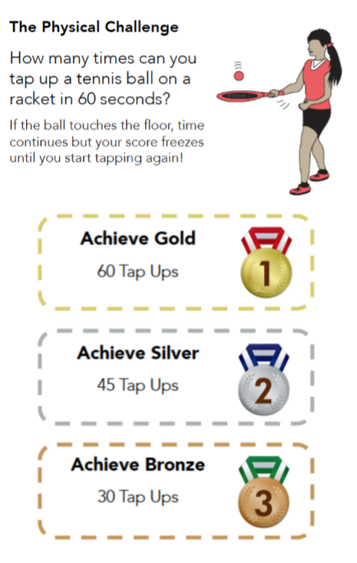
Let your teacher know your scores by posting to dojo

