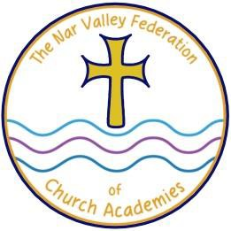

The Nar Valley Federation of Church Academies
“Let Your Light Shine”

Communication Guide and structure

At Nar Valley Federation, we believe that the best education for our children is created when Parents/Carers and school staff work together in partnership. You are your child’s first educators and you know your child best. We value your input and always want to hear views and ideas. Also, if there is ever anything that concerns you, then please let us know as soon as possible so that we can tackle it together and achieve resolution.

If you have queries or ideas then please raise them with the class staff in the first instance. If you need further support, then please go to the Head of School. If you need further clarification, then please speak to Mrs. Neary. If you still require support, then please speak to the Chair of Governors, contactable via the school office at Castle Acre 01760 755305.
If you have a quick query, you are welcome to chat to the staff after school or you can make an appointment at a mutually convenient time. Please contact the school office to make an appointment should you wish to ask for a meeting.

Nar Valley Federation Executive Headteacher
Mrs Anne Neary

Castle Acre Primary Academy | Narborough Primary Academy | Sporle Primary Academy
Head of School | Head of School | Head of School
Mrs Emma Spaul (p/t) | Mrs Sandra Dunkley | Miss Jessy Behan

Federation Business Manager: Mrs Rosemary Ison

The ways in which you can contact us are via email, Parent Mail, Class Dojo or phone call or letter. The office staff monitor the office email and Parent Mail between their normal working hours of 8.30-4.00. Please note that teachers are not able to monitor Class Dojo when they are teaching, so if your message is urgent then please contact the teacher via the school office.
Please note that we will endeavour to answer all emails by the next working day.

If you have a concern, then please raise this with the class staff in the first instance and then the Head of School. If this has not resolved your concern and you feel you have a formal complaint, then please address this in writing to the Head of School via the school office. Please see our complaints policy on our website for the process should this not resolve your concern.

