Monday 4th May 2020
Reception
Phonics
Practise reading words using this game:
https://www.phonicsplay.co.uk/member-only/PictureMatch.html
Pick-A-Picture
Learning the tricky word ‘they’ – Train Your Brain https://www.phonicsplay.co.uk/member-only/TrainYourBrainPh3.html

English: Listen to this story about some very silly animals! https://www.youtube.com/watch?v=N9_AO-kUcmk
Can you write down the rhyming words you hear?
Can you think of another animal trying to get on a different type of transport – have a go at drawing a picture of the animal on the transport!

Maths:
Today we are going to be practising the names of 2D shapes.
Have a go at this activity to sort the shapes into different categories: https://kids.classroomsecrets.co.uk/resource/reception-sort-the-2d-shapes-game/
Can you recognise the shapes in this activity: https://kids.classroomsecrets.co.uk/resource/reception-2d-shapes-recognition-game/

Using cocktail sticks or straws you have in the house, can you build a rectangle, triangle and square? Can you count the sides and corners and write the numbers down, a bit like this: 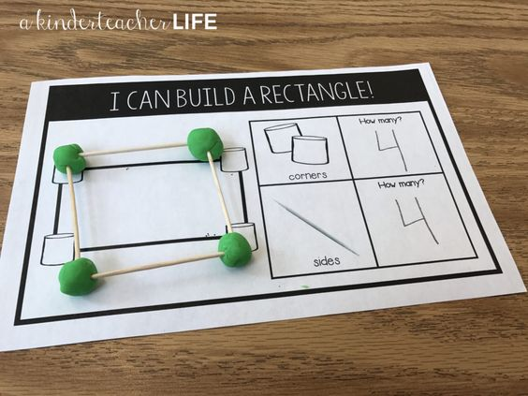
Why is building a circle tricky?
Topic:
The United Kingdom is the name for the part of the world we live in, we live in a part of the United Kingdom. The United Kingdom is split into different countries, Scotland, England, Wales and Northern Ireland. Each of these countries has a capital city, which is where important decisions are often made for the country. Our capital city is called London!
Find out about our capital city and some of its famous landmarks!
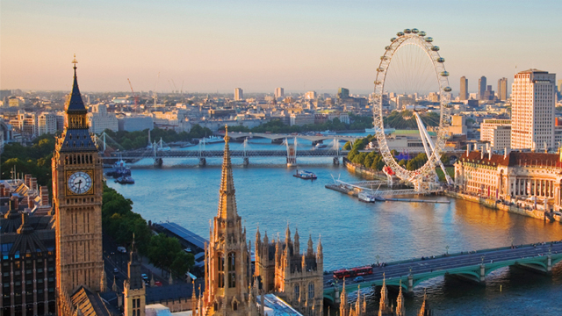
Can you draw them and write one thing you learned too?

