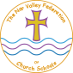

The Nar Valley Federation

Easter activity pack

Why are eggs used as a symbol of Easter?

What do eggs have to do with Easter? What do Christians do with eggs at Easter? Use the internet to find out and record what you find.

____________________________________________________________________________________________________________________________________________________________________________________________________________________________________________________________________________________________________________________
________________________________________________________________________________________________________________________________________________________________________________

Design an Easter egg

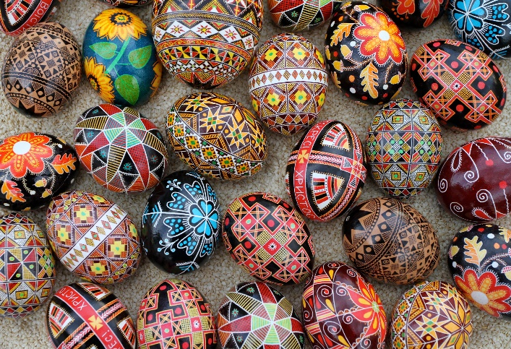

Use the template below to design your own Easter egg. It could be a pattern or a picture.

Hot Cross Buns

Find out about Hot Cross Buns. What are they made of? What time of year are they made? Why do we eat them? What are they a symbol of?
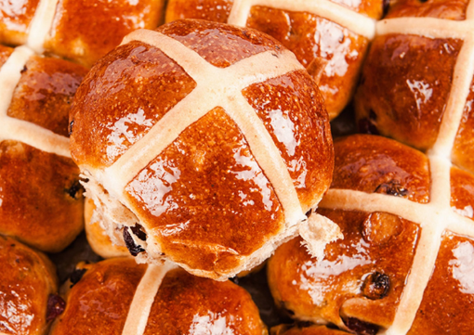

____________________________________________________________________________________________________________________________________________________________________________________________________________________________________________________________________________________________________________________
________________________________________________________________________________________________________________________________________________________________________________

Easter word search

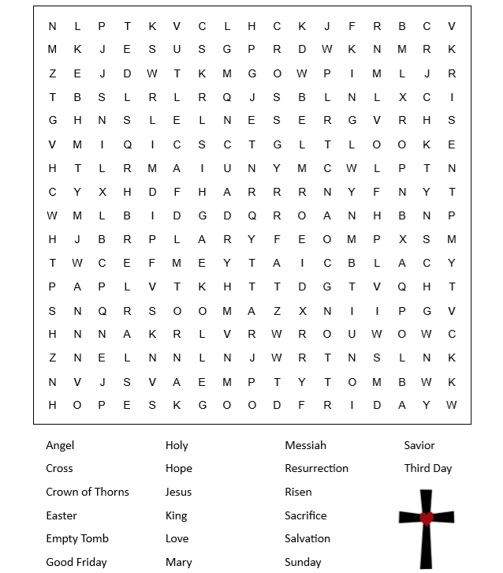

Spring picture challenge

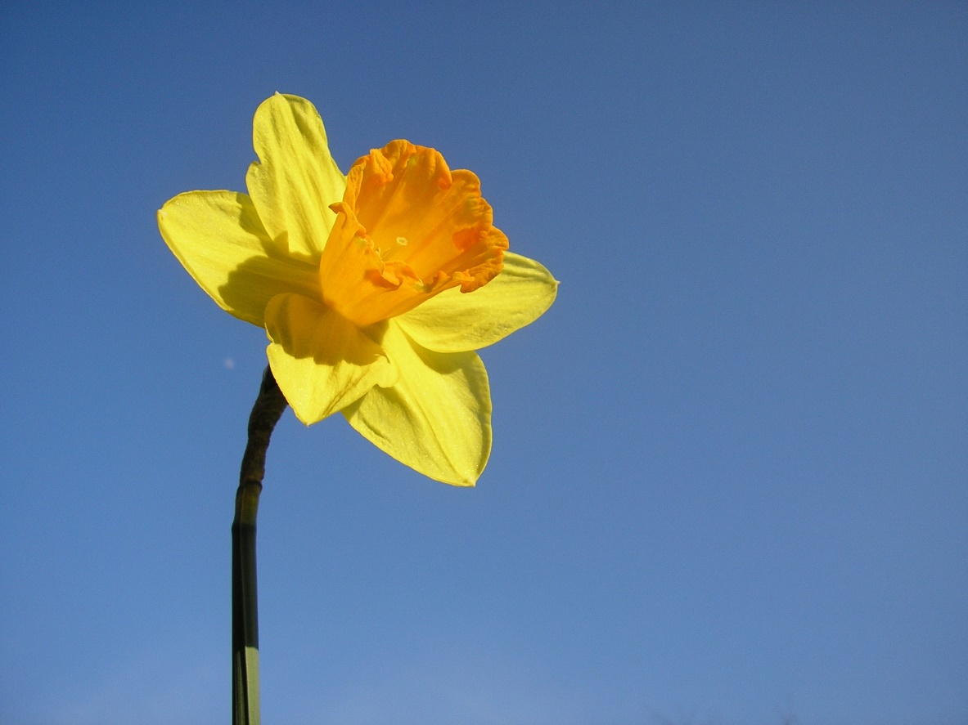

Can you draw this daffodil?

Easter garden

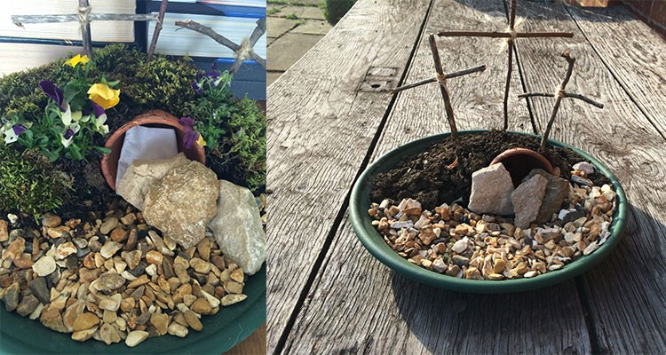

Make an Easter garden with the Children to remind them what Easter is really about.
An Easter garden is more than just a pretty centre piece for your Easter lunch, it is a way to help teach children about Jesus and how he died for us and rose into Heaven. They were a big part of my church’s Good Friday and Easter Sunday services so this year I thought I would make one with my charges to help them understand Easter is not just about chocolate.
For your own garden you will need:
- A tray
- Soil
- Grass seeds or moss
- Small stones
- A large stone
- A piece of small white cloth
- A small flower pot
- 6 sticks to make into 3 crosses
- String
1. Place your flower pot on its side on the tray (this will be tomb) and cover half the tray (including over the side of the flower pot) with soil, this will make a hill side. On the other half put your small stones.
2. If you are doing this with over week before Easter you could always plant some grass seeds in the soil and watch them grown. If like us you don’t have that long find some moss that is growing on a wall and peel it off to cover the soil area. We also dug up some pansies that were growing between some paving stones in the garden to add some colour to our garden.
3. With your sticks use them to make three crosses and secure them with bits of string. Stick them into the top of the “hill”, if you have one cross that is bigger than the others, place it in the centre of the three crosses to represent the cross which Jesus was crucified on.
4. Finally with the piece of white cloth, fold it up and put it in the tomb and place the large stone in front of the entrance to the tomb. On Easter Sunday roll the stone away to show that Jesus has risen.
Even if you aren’t religious this is a simple activity to do to teach children about different cultures and religions.

Easter bonnet
Why not try making an Easter bonnet with your children. For some good examples visit
https://blog.partydelights.co.uk/how-to-make-an-easter-bonnet/

